**Saving Deposit Error as at 30-June-2016**

1. **TANG MOUYLENG-260000012078-No Maturity Date, Interest Rate and Pay Account**

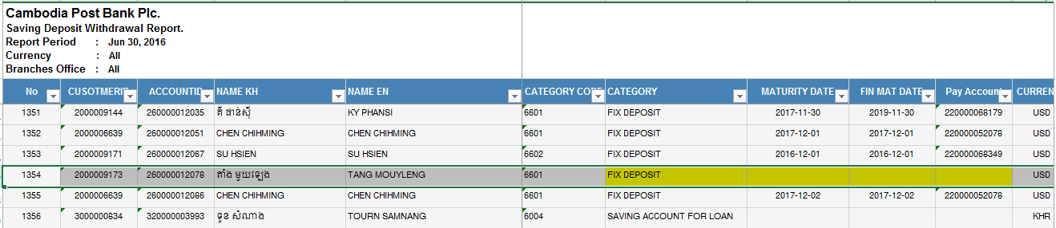

1. **CHHOEM THOU-420000037248-Minus Balance**

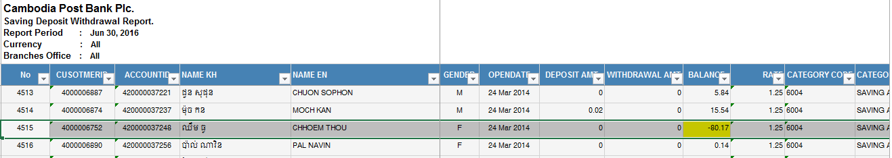

1. **BIT SABAN-220000061298-Minus Balance**

